Circle Language Spec: Commands

Active Command in Inactive Command in a Diagram
The article Active Clause in Inactive Command explained a rule about active commands in inactive commands. The current article further clarifies it with a diagram.

A clause in a clause only ever runs when its top parent command is an active command object. If the top parent command is an inactive command object, for instance a command definition, then even an active clause in it is dormant.

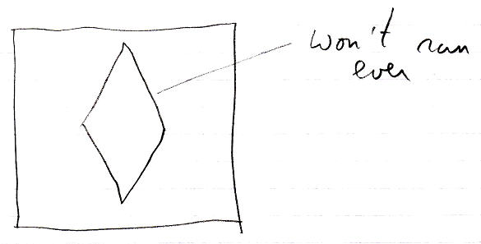

The clause will only ever run in a call to the definition, but then it is a copy of the definition’s clause:

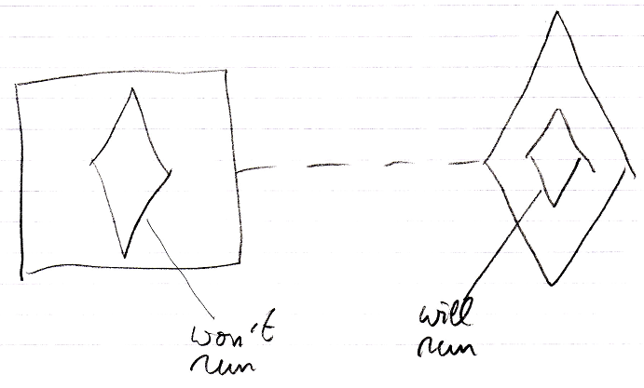

An executable command inside a command definition can not be run, because its parent is dormant, and an executable sub-command can not be referenced from elsewhere either.

